
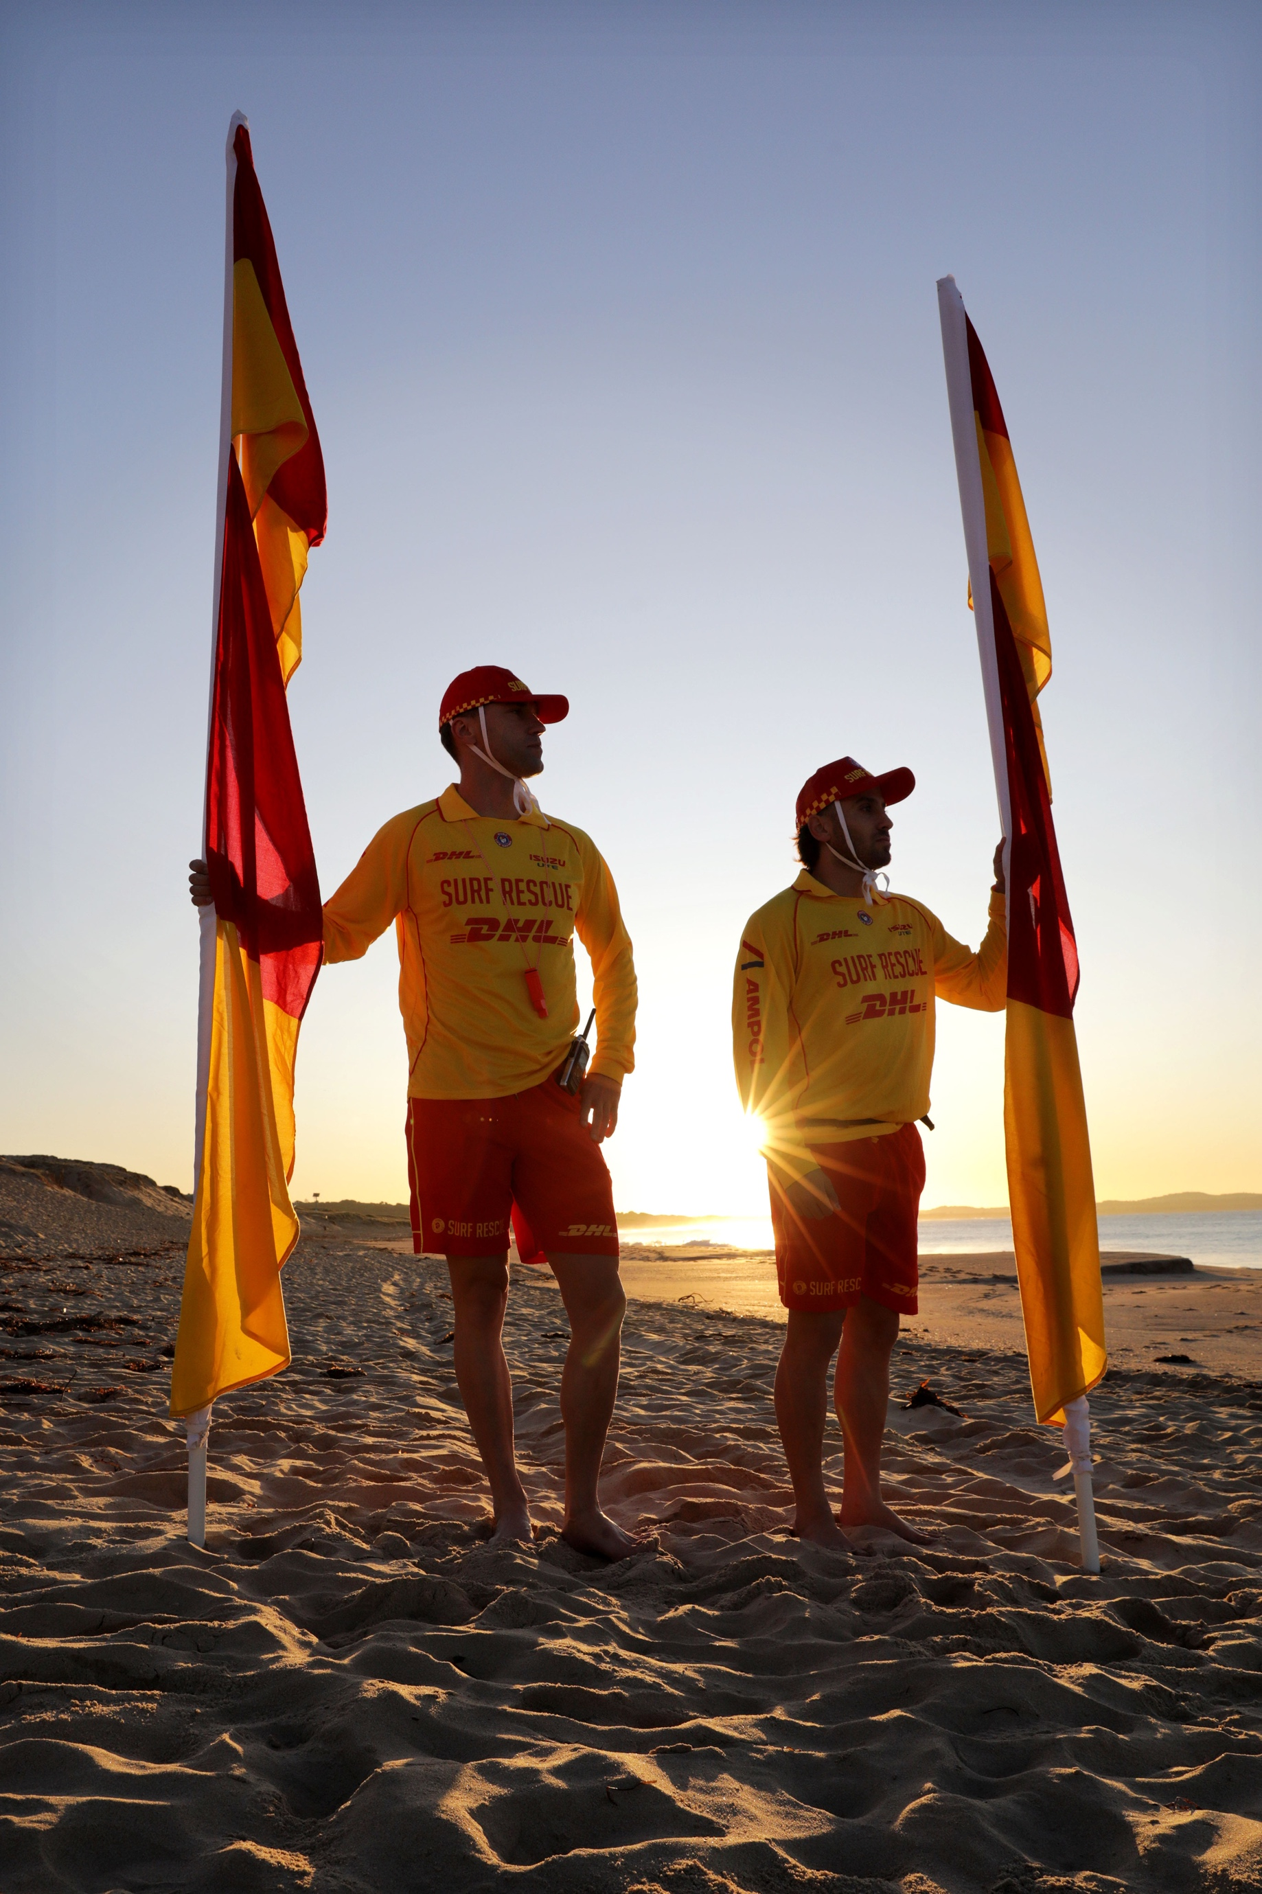

Patrol Operations Manual

_______ SLSC

Table of Contents
- Patrol Operations 3
  - Surf Life Saving & Emergency Services 3
  - Club Radio Procedures 5
  - Club Callout Team 6
- Hazards & Dangers 7
  - Beach Morphology & Hydrodynamics 7
  - Hazard Map 8
  - Hazard/Risk Management 8
- Beach Management 10
  - Equipment Location 10
  - Local Government By-Laws 10
  - Opening of Patrol (Start of Patrol) 10
  - Closure of Patrol (End of Patrol) 11
  - Nippers/Water Safety 11
- Emergency Operations Plans 12
  - Emergency Beach Closure 12
  - Emergency Beach Closure Procedure 12
  - Tsunami Plan 13
    - Notification 13
    - Key Equipment 14
    - Marine Threat Response 14
    - Land Threat Response 14
  - Coastal Flooding Plan 15
    - Coastal Flooding Response 15
  - Emergency Rally Point 16
- Standard Operating Procedures 17

Patrol Operations

Surf Life Saving & Emergency Services

SurfCom
Service | Phone | Email
SOC General Line | 02 9471 8092 | soc@surflifesaving.com.au
SOC Emergency Line | 02 9471 8091 | soc@surflifesaving.com.au
Emergency services such as Police, Ambulance, Fire, Helicopters, Roads and Maritime Services, Marine Rescue,
National Parks and Wildlife Services and the NSW Department of Primary Industries should be requested via SurfCom

Location Details
Street Address: | _____________________
What 3 Words: | ________ SLSC: ///___________  4WD Access: ///__________  Sea Wall: ///_________
Nearest Cross Street: | __________ x _________
Emergency Rally Point: | _____________________

Local Stakeholders
STAKEHOLDER | PHONE NUMBER | STAKEHOLDER | PHONE NUMBER
STAKEHOLDER | PHONE NUMBER | STAKEHOLDER | PHONE NUMBER
STAKEHOLDER | PHONE NUMBER | STAKEHOLDER | PHONE NUMBER
STAKEHOLDER | PHONE NUMBER | STAKEHOLDER | PHONE NUMBER
STAKEHOLDER | PHONE NUMBER | STAKEHOLDER | PHONE NUMBER

Patrol Times 2025/2026
Period | Date | Saturdays | Sundays + Pub Hol
1 | ________________ | ________________ | ________________
2 | ________________ | ________________ | ________________
3 | ________________ | ________________ | ________________
4 | ________________ | ________________ | ________________
5 | ________________ | ________________ | ________________

Club Officer Details
Club Position | Name | Phone Number | Email Address
President | ________________ | ________________ | ________________
Vice President | ________________ | ________________ | ________________
Club Captain | ________________ | ________________ | ________________
Vice Club Captain | ________________ | ________________ | ________________
Gear Steward | ________________ | ________________ | ________________
Radio Officer | ________________ | ________________ | ________________
IRB Captain | ________________ | ________________ | ________________
Board Captain | ________________ | ________________ | ________________
Chief Training Officer | ________________ | ________________ | ________________
Caretaker | ________________ | ________________ | ________________
JA Water Safety Mgr | ________________ | ________________ | ________________
Patrol 1 Captain | ________________ | ________________ | ________________
Patrol 2 Captain | ________________ | ________________ | ________________
Patrol 3 Captain | ________________ | ________________ | ________________
Patrol 4 Captain | ________________ | ________________ | ________________
Patrol 5 Captain | ________________ | ________________ | ________________
Patrol 6 Captain | ________________ | ________________ | ________________
Patrol 7 Captain | ________________ | ________________ | ________________
Patrol 8 Captain | ________________ | ________________ | ________________
Patrol 9 Captain | ________________ | ________________ | ________________
Patrol 10 Captain | ________________ | ________________ | ________________
Patrol 11 Captain | ________________ | ________________ | ________________
Patrol 12 Captain | ________________ | ________________ | ________________

Neighbouring Surf Life Saving Clubs
Surf Life Saving Club | Phone Number | Email Address
________________ | ________________ | ________________
________________ | ________________ | ________________
________________ | ________________ | ________________
________________ | ________________ | ________________
________________ | ________________ | ________________
________________ | ________________ | ________________
________________ | ________________ | ________________
________________ | ________________ | ________________
________________ | ________________ | ________________
________________ | ________________ | ________________



HOLD for inclusion of the SLSNSW State Operations Centre (SOC) standard operating hours and communication/radio pathways. The SOC are still preparing this guidance and SLSS will send through the content for inclusion when it is available.

In the event of an Emergency:
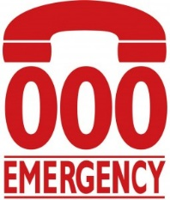
During operational hours, contact Surfcom for 000 assistance.
For out-of-hours assistance, call 000 & notify the rostered State Duty Officer via 02 9471 8091

Club Radio Procedures

Emergency Callout Team
Due to the benefit to the community, all volunteer lifesaving services in NSW should have emergency response (24/7) callout capability. This should be achieved through a coordinated system of suitably qualified personnel with access to appropriate rescue equipment.
Members of the ‘Emergency Callout Team’ are to be appointed by the Club Captain with a list of active members (over the age of 18) maintained via SurfGuard.
To maximise emergency response effectiveness and personnel safety, clubs should maintain the following equipment/logistical preparedness at a minimum;
- 2 x rescue tubes (with fins)
- 2 x rescue boards
- IRB (with trailer and full fuel bladder in an accessible location)
- SSV (if applicable)
- 1 x defibrillator
- 1 x oxy resuscitation kit
- 1 x first aid kit
- 1 x spinal board (with spinal collars)
- 2 x handheld radios in waterproof bags
- Personal telephone numbers contactable 24 hours with contacts (updated in SurfGuard)

Lifesaving services and/or personnel may decline a request to respond to an emergency if they feel it would create a level of unacceptable risk to do so. Examples of inhibitor may be:
- Insufficient personnel
- Insufficient equipment
- Dangerous conditions
- Geographical distance (outside achievable response area)

Appropriate local emergency response planning/preparedness (equipment and procedures) will minimise the above inhibitors and maximise the ability to render assistance.

Hazards & Dangers

Beach Morphology & Hydrodynamics
Insert ‘Beach Morphology and Hydrodynamics’ paragraph and image from your Surf Life Saving Club’s Supervision and Surveillance Report

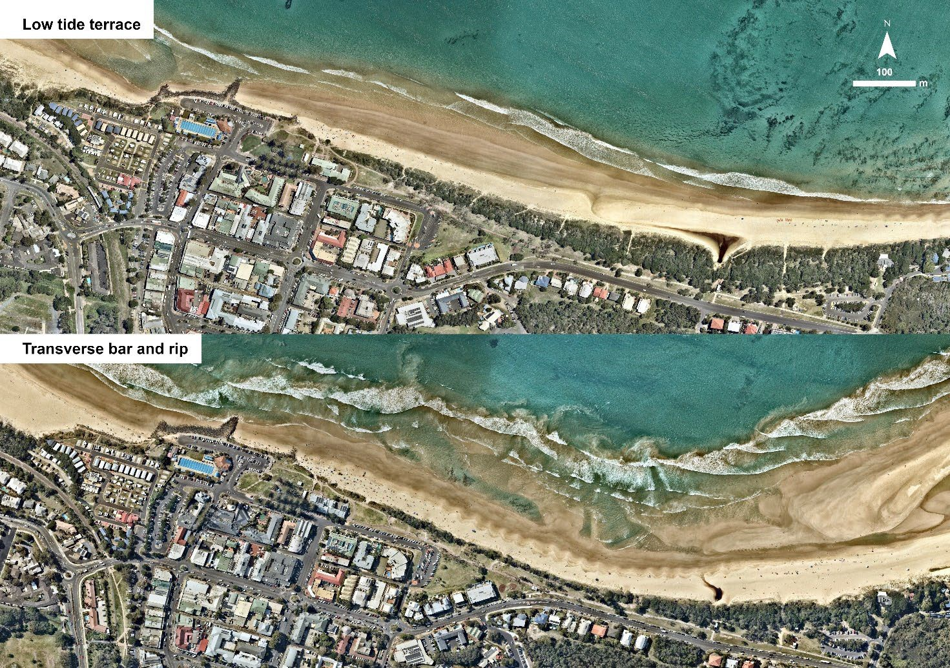
EXAMPLE

Hazard Map
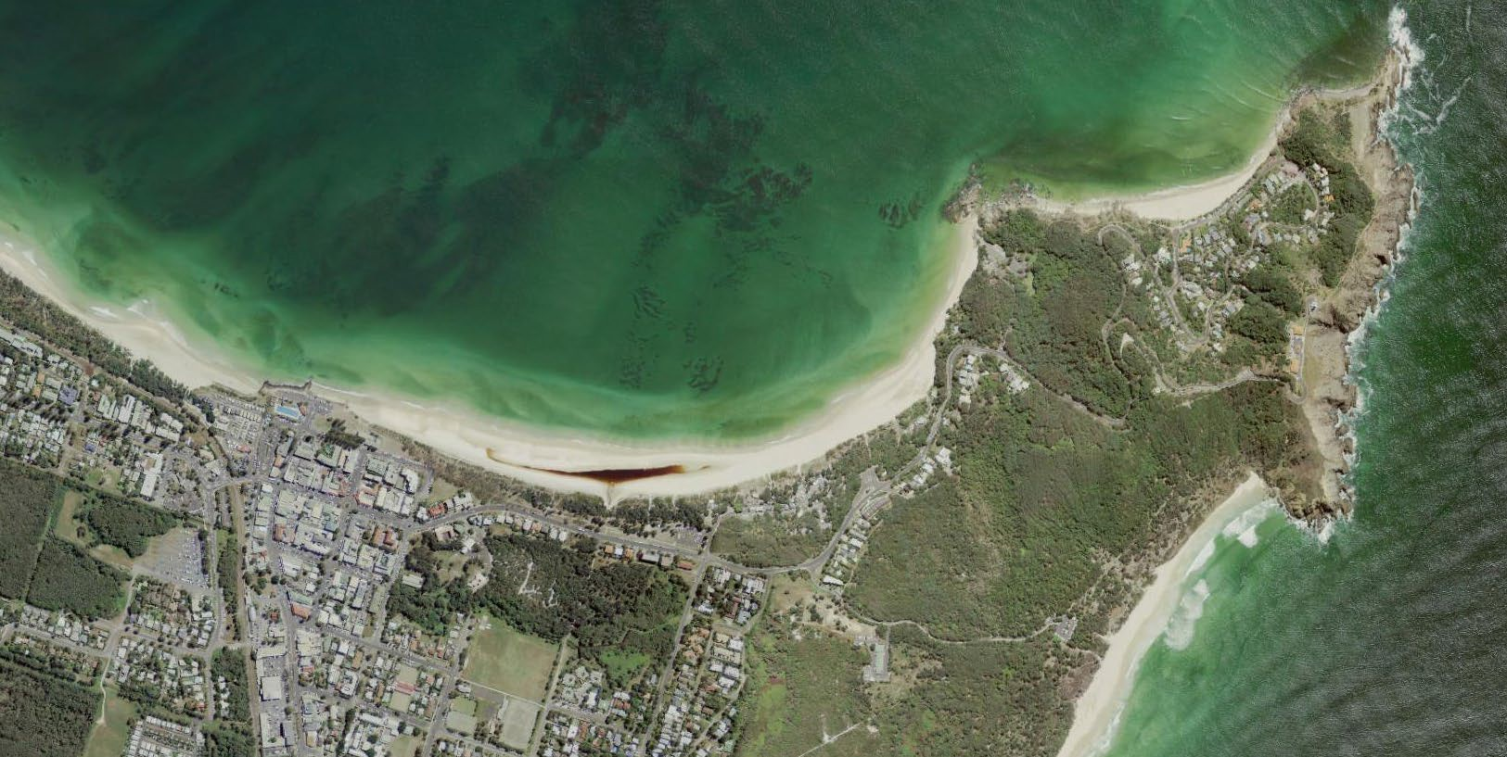

EXAMPLE
Little Wategos
Wategos
Bullies Beach
The Pass
The Wreck
Cape Byron
Cosy Corner
Tallows Beach

Hazard/Risk Management

Hazard | Dangers
‘The Wreck’ | A large shipwreck approx. 400m North of the regular patrol area. A common place to snorkel and to climb and jump off into water. Dangers include:  - Large waves  - Strong currents  - Deep and/or shallow water  - Sand banks  - Rocks (Inc. submerged)  - Poor visibility from the patrol area  EXAMPLE  - Large pieces of rusted metal under and above the water
Tallows Beach | Dangers include:  - Strong currents  - Large waves  - Sand banks
Cosy Corner | Situated at the most northern end of Tallow Beach, it is also on the southern end of Cape Byron. Dangers include:  - Strong currents  - Large waves  - Sharp rocks and ledges  - Slippery rocks  - Sand banks  - Submerged rocks

Beach Management

Equipment Location

Item | Location
IRB | _______
Side-by-side vehicle | _______
Radios | _______
Patrol shade (tent) | _______
Rescue boards | _______
Rescue tubes | _______
Defibrillator | _______
Oxy resuscitation kit | _______
First aid kit | _______
Spinal board | _______
Binoculars | _______
Patrol flags/signage | _______

Local Government By-Laws

Local By Law | Management Plan
Dogs Prohibited on Beach | _______
No Vehicles on Beach | _______
No Alcohol on Beach | _______
No Smoking on Beach | _______
No Fires on Beach | _______
No Camping or Overnight Stays | _______

Opening of Patrol (Start of Patrol)
The flagged area should be located in the safest area for swimming and should be opened as wide as possible where conditions, activities and resources allow. The flags and rescue equipment must be moved with the rise and fall of the tide to keep them at the waters edge.
It is the responsibility of the Patrol Captain to ensure that all emergency equipment is in place and in working order. All patrolling equipment shall be checked on each deployment, with specific attention to the condition and operability of; power craft, rescue equipment, first aid and resuscitation equipment.
Any damaged or missing equipment shall be reported in the log, tagged and communicated ASAP to the Club Captain and/or Gear Steward.

Equipment Type | Necessary Checks
Oxygen Resuscitation Kits | System test and miscellaneous equipment check.  Check oxygen cylinder is over ½ full.  It is strongly recommended that at least 1 full backup cylinder is available.
Defibrillators | System test and miscellaneous equipment check
First Aid Kits | Condition and contents check
Powercraft | Inflatable Rescue Boat (IRB) checks  Side-by-Side (SSV) Vehicle checks  4WD Vehicle checks
Rescue Equipment | Rescue board checks  Rescue tube and fins checks
Radios | Fully charged and operational  TWO radios to channel 2 (patrol) and TWO to channel 3 (SurfCom)

Closure of Patrol (End of Patrol)
When disestablishing the flagged patrol area, the following steps should be taken to ensure rescue readiness is maintained, and effective communication is utilized to ensure the safety of beachgoers;
- Refer to Lifesaving Service Agreement and identify whether extended times (above minimum hours) are required due to patronage or conditions.
- Inform SurfCom of closure or if extending patrol operations, notify Surfcom 30 mins prior.
- Utilise the public announcer or similar to inform swimmers of closure and recommend they cease swimming for the day.
- Utilise in-water lifesaving personnel to inform public of closure.
- Consider a roving patrol to adjacent areas to inform public of closure.
- Repeat communication of closure and warning of hazards to remaining swimmers if required.
- Maintain surveillance of water while equipment is packed up for the day.
- Maintain dedicated rescue equipment on-standby while other equipment is packed up for the day.
- Prepare after-hour/call out response equipment (rescue-ready).
- Conduct a final sweep of surf area before packing up standby equipment and leaving the beach.
- Notify relevant club/service/branch officers/supervisors of any issues (i.e. Equipment damage, consumable/fuel shortages etc).

Nippers/Water Safety
Nipper activities (and like activities) are to adhere to the SLSA Water Safety Policy (SLSA Policy 1.01) at all times. Nipper activities are to only be conducted in the immediate vicinity of an active patrolled area and have its own sufficient water safety (as detailed in SLSA Water Safety Policy 1.01A). It is highly recommended that an IRB be available water safety. The IRB should be on the water, rather than stationary on the beach.
Nipper water activities cannot be undertaken on a closed beach.

NOTE: the Patrol Captain/Lifeguard is the ultimate authority on the beach (notwithstanding Local and State Government requirements / Legislation).

Drone surveillance

SLSNSW has launched the 2026/27 UAV schedule for shark mitigation. These UAV are tasked with shark monitoring across our coastline.

Pilots across the state are trained in First Aid and carry First Aid Kits inclusive of Trauma Kits. They have portable loudhailers that have an inbuilt evacuation alarm to more broadly alert public should an evacuation be required upon a sighting. All communication regarding a sighting is relayed to the State Operations Centre (SOC)

If a pilot sees a swimmer in distress they will communicate directly with the SOC and we will implement an immediate response through patrol or standard call-out processes. Having this broad coverage will reduce any response time should such an event unfold.

*** Delete if not relevant for your Club***
_____ has a shared access agreement with SLSNSW to store a drone in X.
.

Waverley | Tamarama/Bronte Beach Bondi/North Bondi | Everyday
Randwick | Clovelly (Incl. Gordons Bay) Maroubra/South Maroubra Beach Coogee Beach  Malabar  Little Bay | Everyday
Sutherland | Wanda/Greenhills Beach Elouera/North Cronulla/ Cronulla Beach | Everyday

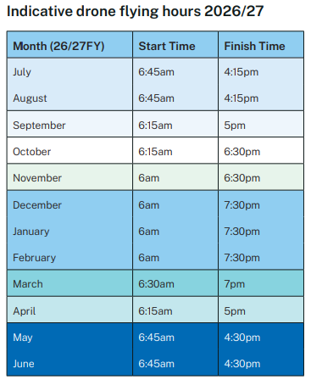

Emergency Operations Plans

Emergency Beach Closure
Patrol Captains should consider the ‘closure’ of a beach at any time that there is an unacceptable and/or unmanageable risk to the public or the lifesaving service is unable to effectively and safely perform their duties. For a detailed procedure, refer to Standard Operating Procedure ‘PSS 8.1 Emergency Beach Closure and Evacuation’.
Examples include;
- IRB not operational
- Dangerous surf conditions
- Sharks
- Excessive stingers
- Powercraft hazards
- Lightning
- Tsunami/flood warning
- Storm pollution
- Chemical/fuel spill

Emergency Beach Closure Procedure
- Determine if water area is to be evacuated.
- Log the beach closure through the Operations App (where available) and inform SurfCom via radio on channel 3 that you are about to close the patrolled area and the reason for closing.
- Activate the Emergency Evacuation Alarm.
- Inform everyone of the following:
  - Water area is being closed; and
  - Reason for closure.
- Lower and remove the red and yellow patrol flags and black and white surfcraft flags.
- Post ‘Swimming Not Advised’ signs at identified beach access points and where the flagged area was located.
- Continually monitor all areas.
- Maintain minimum personnel, qualification and equipment requirements.
- Maintain an active presence on the beach to advise/warn public.
- An appropriate record should be made in the patrol log giving an outline of the incident.
- Where required liaise with Emergency Services
Generally, the beach will remain closed until such time as the identified hazard is controlled or no longer presents a risk.
Recommended closure periods include;
- Dangerous surf conditions – as determined/appropriate
- Shark sighting – at the discretion of the Patrol Captain and/or Duty Officer
- Chemical/biological hazards – after confirmation from appropriate authorities that the area is safe

In the event of beach closure due to shark sighting, please refer to SLSNSW Public Safety Standard Operating Procedures PSS 8.5. In the event of a shark sighting that qualifies for beach closure:
- Activate the Emergency Evacuation Alarm (continuous tone);
- Inform everyone that the beach is being closed due to a shark sighting and strongly recommend they leave the water;
- Lower and remove red and yellow patrol flags and all other flags;
- Post ‘Swimming Not Advised’ signs at identified beach access points;
- Post ‘Shark’ hazard sign where patrolled area was located;
- Continually monitor all areas from an elevated position (i.e. tower) and through the use or power-craft and aerial assets (if available);
- Do not attempt to kill, capture or injure the animal;
- Contact SurfCom (or similar) and inform them of the shark sighting and status of patrolled area (i.e. closed);
- The patrolled area should remain closed until after a full search of the area has been completed and the Patrol Captain/Lifeguard is confident that there is no obvious risk to swimmers, surfers and other beach- users posed by the shark; and
- Complete Shark Report Form and forward to SLSNSW.

Tsunami Plan

Surf Life Saving New South Wales is recognised under the State EMPLAN as a ‘support agency’ in a Tsunami event. Broadly, our role includes;

Contribute to tsunami community education initiatives

Assist the SES with the dissemination of warnings

Close and evacuate beaches on receipt of a NSW Tsunami Warning or upon observation of unusual ocean behaviour indicative of a tsunami, in consultation with Local Government Councils

Assist with the rescue of people from the surf zone following the impact of a tsunami

Notify the SES when unusual ocean behaviour indicative of a tsunami is observed or a tsunami has occurred for which there has been no prior warning

For a detailed procedure, refer to Standard Operating Procedure ‘PSS 8.11 Tsunami Warning’ and the ‘Surf Life Saving New South Wales Tsunami Plan.’

Each Surf Life Saving Club has an obligation to be prepared and respond as outlined in the ‘Surf Life Saving New South Wales Tsunami Plan’.

There are two types of tsunami threats;

Marine threat – may influence currents/rips/water energy and immediate foreshore (more common)

Land threat – may impact coastal areas, inlets and inland inundation (rare event, but significant impact)

Notification

The SES is the ‘lead agency’ for tsunami response and will advise Surf Life Saving of a tsunami warning through the State Duty Officer, who will co-ordinate the Surf Life Saving response.

Due to the location of ‘fault lines’ (starting points of tsunami’s) a warning should precede the tsunami impact by a number of hours.

Depending on the time of day/year, the notification process will differ, however will remain similar to the standard emergency response notification;
Patrols on duty

State Duty Officer notifies SurfCom and Branch Duty Officer

SurfCom advises on duty patrols of tsunami warning and to activate their ‘Club Tsunami Response Plan’
Patrols not on duty

State Duty Officer notifies Branch Duty Officer

Branch Duty Officer notifies ‘Club Emergency Response Teams’ who activate their ‘Club Tsunami Response Plan’

Key Equipment

The following equipment (minimum) is key to maintaining a viable lifesaving service during a tsunami warning (both marine and land threat) and restoring the service following the impact of a tsunami to a ‘rescue ready’ status. This equipment should be moved to a safe location prior to the tsunami’s impact (marine and land threat);

IRB (with trailer)

3 x handheld radios in waterproof bags

2 x ‘swimming not advised’ (or ‘beach closed) mobile signs

1 x binoculars

Marine Threat Response

Club advised of tsunami warning

Patrol/flagged area closed

Evacuation alarm sounded (continuous siren)

Evacuation flag erected (red and white quartered)

Swimmers/surfers etc evacuated from water

Members of the public evacuated from foreshore

‘No swimming’ signage erected

Relocate key patrol/response equipment away from the foreshore

Prepare to evacuate all personnel and key equipment if warning is upgraded to a ‘land threat’

Maintain preparedness to respond to emergencies until threat has passed (official notification from SurfCom/Branch Duty Officer)

Upon clearance from SurfCom/Branch Duty Officer return to normal operations (stand down)

Land Threat Response

Club advised of tsunami warning

Patrol/flagged area closed

Evacuation alarm sounded (continuous siren)

Evacuation flag erected (red and white quartered)

Swimmers/surfers etc evacuated from water

Members of the public evacuated from foreshore, car park and immediate area

‘No swimming’ signage erected

All non-essential personnel sent home

Transport ‘key equipment’ and remaining personnel to pre-determined rally point (see 5.6 Emergency Rally Point)

Inform SurfCom/Branch Duty Officer when evacuation to rally point is complete

Maintain preparedness to respond to emergencies until threat has passed (official notification from SurfCom/Branch Duty Officer)

Respond to incidents following tsunami impact as directed by SurfCom/Branch Duty Officer

Upon clearance from SurfCom/Branch Duty Officer return to normal operations (stand down)

Coastal Flooding Plan
Surf Life Saving New South Wales is recognised under the State EMPLAN as a ‘support agency’ in a coastal flooding event. Broadly, our role includes;
- Assist the SES with the warning and/or evacuation of at risk communities
- Provide space in Surf Life Saving facilities for evacuation centres where required
- Assist the SES with flood rescue operation
For a detailed procedure, refer to Standard Operating Procedure ‘PSS 8.10 Coastal Flooding.’
Each Surf Life Saving Club has an obligation to be prepared and respond in line with a ‘land threat’ tsunami warning.
Coastal areas are likely to be affected by either ‘flash flooding’ or ‘storm surge’ flooding. ‘Storm surge’ flooding will generally coincide with high tides and is easier to predict and prepare for. ‘Flash flooding’ is unpredictable and occurs in a short period of time, occasionally a storm warning may be issued prior to the flooding event.

Coastal Flooding Response
- Club advised of coastal flooding warning
- Patrol/flagged area closed
- Evacuation alarm sounded (continuous siren)
- Evacuation flag erected (red and white quartered)
- Swimmers/surfers etc evacuated from water
- Members of the public evacuated from foreshore, car park and immediate area
- ‘No swimming’ signage erected
- Prepare Clubhouse as an ‘emergency evacuation centre’
- All non-essential personnel sent home
- Transport ‘key equipment’ and remaining personnel to pre-determined rally point (see 5.6 Emergency Rally Point)
- Inform SurfCom/Branch Duty Officer when evacuation to rally point is complete
- Maintain preparedness to respond to emergencies until threat has passed (official notification from SurfCom/Branch Duty Officer)
- Respond to incidents as directed by SurfCom/Branch Duty Officer
- Upon clearance from SurfCom/Branch Duty Officer return to normal operations (stand down)

Emergency Rally Point
______________
What 3 Words: ///_________
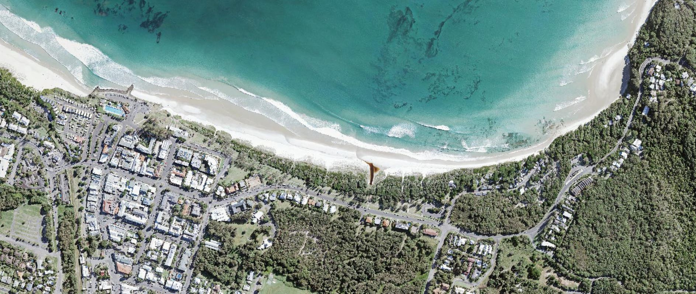

EXAMPLE

Standard Operating Procedures
For detailed information on Lifesaving procedures and policies, refer to the Public Safety Standard Operating Procedures on the Surf Life Saving New South Wales website.
- PSS 1 Work Health and Safety
- PSS 2 Information Management
SLSNSW Public Safety
Standard Operations Procedures
- PSS 3 Obligations and Standards

- PSS 4 Regulations – Rescue Vessels
- PSS 5 Gear and Equipment
- PSS 6 Radio Communications
- PSS 7 Patrol Operations (General)
- PSS 8 Patrol Operations (Emergency)
- PSS 9 Surf Emergency Response System
- PSS 10 SAR Operations
- PSS 11 Surfcom
- PSS 12 Vessels and Aircraft
- PSS 13 Post-Incident

