<Insert Club Logo here>

Dear Participant
We are pleased to confirm and welcome your attendance at the SLS course as per below details :
First Aid Course
Course Contact: |  | Date(s):
Contact email: |  | Time(s):
Contact phone: |  | Duration:
Course Facilitator |  | Venue(s):
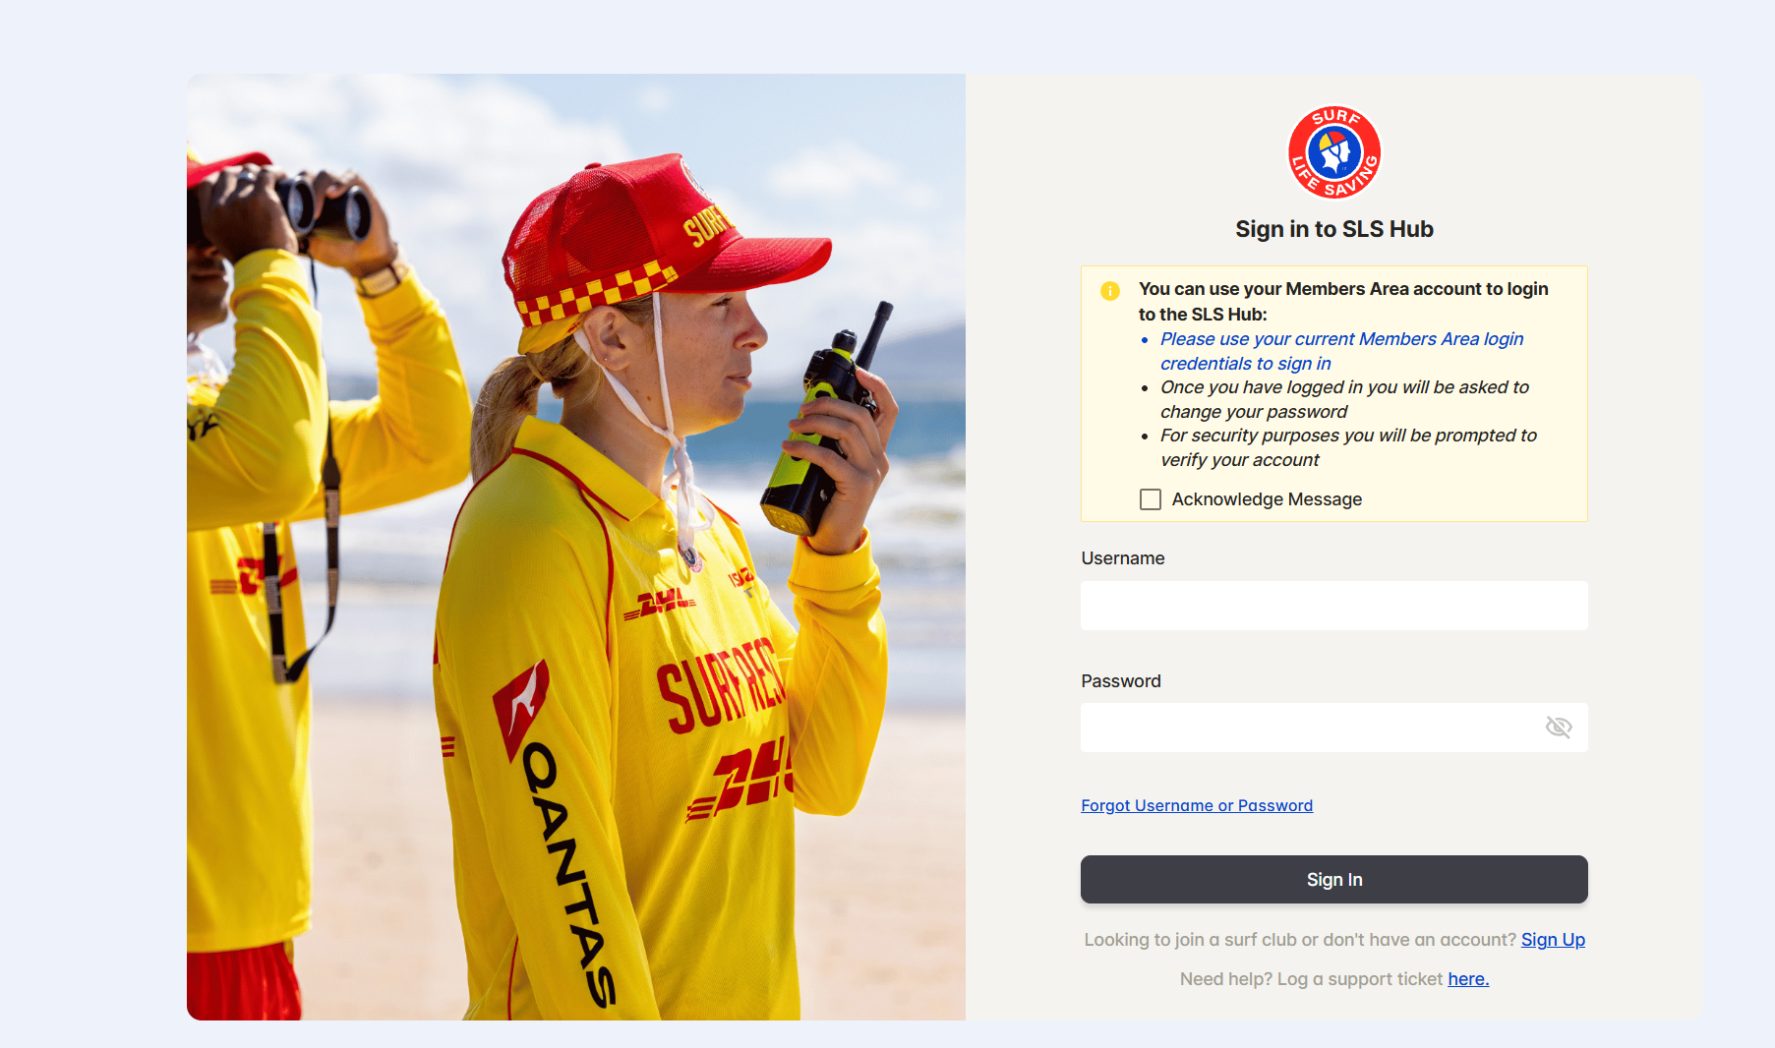
To help you achieve your First Aid award and prepare for the course, please follow the steps outlined below:
- Access your SLS Hub account (Click here if you need to create your own account.
If you have forgotten your username and password, click here to receive them via email or text)

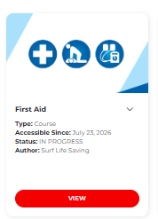
- Complete this Training Enrolment Form (If you are under 18, your parent or guardian will need to sign the Training Enrolment Form on your behalf. Bring it with you to the course.)

- Prior to attending the course you need to completed the First Aid pre-course workbook which is available in E-learning section of the SLS Hub. You can find it under e-learning—>training library—>SLSNSW - Emergency Care—>First Aid.

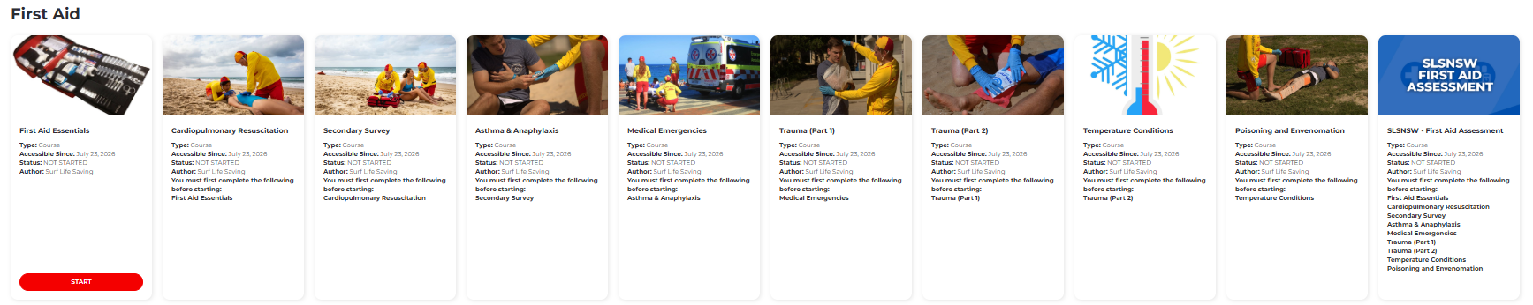

- In lieu of a text book, your reference materials are available online. There is a series of factsheets on the SLSNSW website that cover off on the topics discussed in the First Aid course (candidates will be provided hard copies of these at the course) - https://services.surflifesaving.com.au/first-aid-fact-sheets

- Download the following course resources:
- SLSNSW Participant Handbook (Contains information about RPL, codes of conduct, appeals, and complaint processes)
- Assessment Portfolio will be provided at course
It is our aim to cater for the special needs of all our participants. If you feel you have additional learning needs or may require extra assistance, please speak with your trainer before the first day of your course or at your induction session. Please note that Surf Life Saving NSW is exempt from certain national reporting requirements, including those relating to the Unique Student Identifier (USI) scheme. As a result, this training will not appear on your authenticated VET transcript available from the Student Identifiers Agency.
We trust that we have anticipated your enquiries, however, if you have any questions please contact your club CTO, in the first instance or reach out to Branch office education@sls.sydney
______________________________________

